(Approx. 513 words)

3D Printing
by Jeff Wilkinson, President
Sun City Summerlin Computer Club
https://www.scscc.club
clearmeadows11 (at) gmail.com
Recent articles extolled the advantages of 3D printed houses, so I thought it might be time to take a look at what all the fuss is about. 3D printers have been around for a while now, and a few club members have them and have created some very interesting and useful items. To support the growing demand of small business customers, some UPS stores now offer 3D printing services. Industrial applications grow every day, and volume manufacturing is now a reality. Meanwhile, rapid prototyping is still an efficient and practical tool used in product development.

3D printing is an additive process, with material deposited in successive layers. Using a computer allows for the creation of a three-dimensional item. Plastics and metal alloys are the most commonly used materials, but the 3D-printed house takes it a step further with concrete.

An outgrowth of printing as we know it, where ink is laid down on a substrate, generally paper, in a thin layer, 3D printing lays down material in successive layers building up the height. Thus, 3D printing saves material over a subtractive process such as milling, sawing, and shaping by removing material in a manufacturing environment. Instead, materials can be laid down precisely by the computer-controlled “print head.”

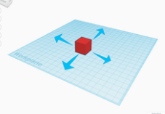
The 3D printing process begins with a design. Beginners and hobbyists can use a program such as Tinkercad, a browser-based application that allows you to create and then export your design as a .STL or .OBJ file compatible with 3D printers. The file is then “sliced” or split into hundreds or thousands of layers; this is done with software. Your sliced file is now ready to be sent to your printer.

The setup and calibration of the printer are very important, and the time to print is a function of the complexity of the part. One of our club members recently designed and built some jigs to locate and drill holes for new cabinet hardware. Each jig took just over 2 hours to print using ABS plastic filament. The result is a useful tool pictured below.

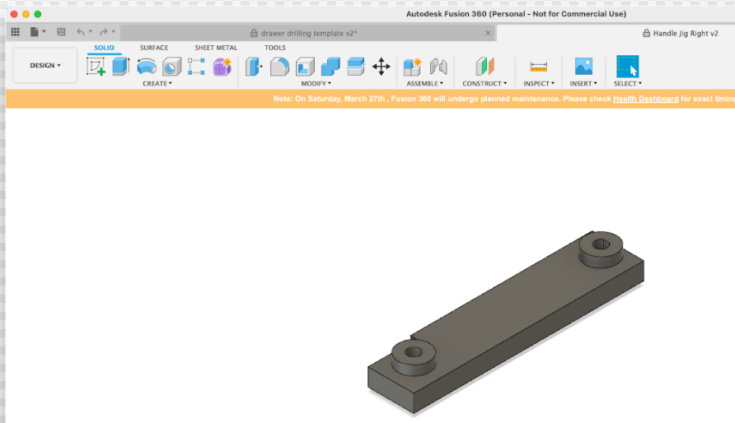
Design

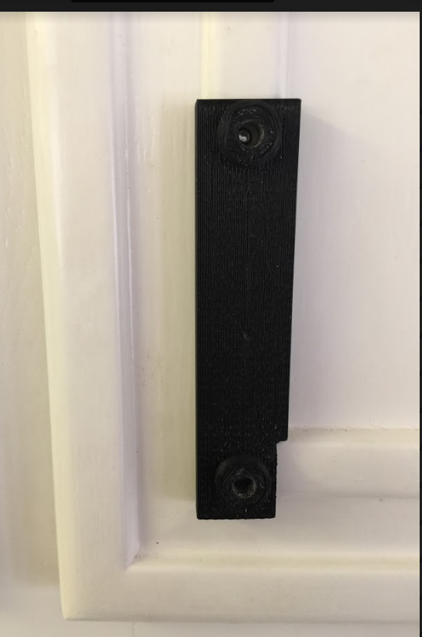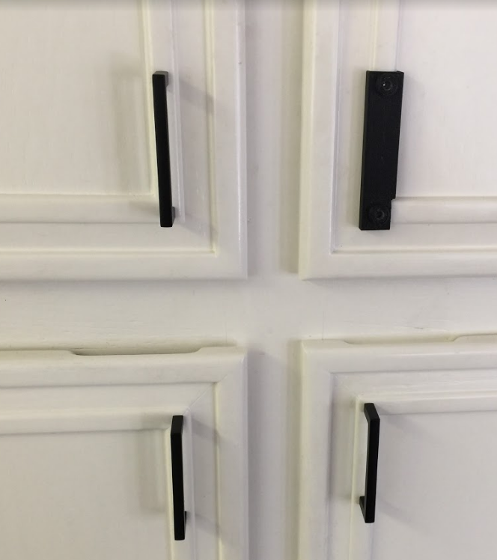
Jig on cabinet door
Holes drilled and new hardware successfully installed

Custom jig to locate and facilitate drilling of holes to mount new cabinet hardware.

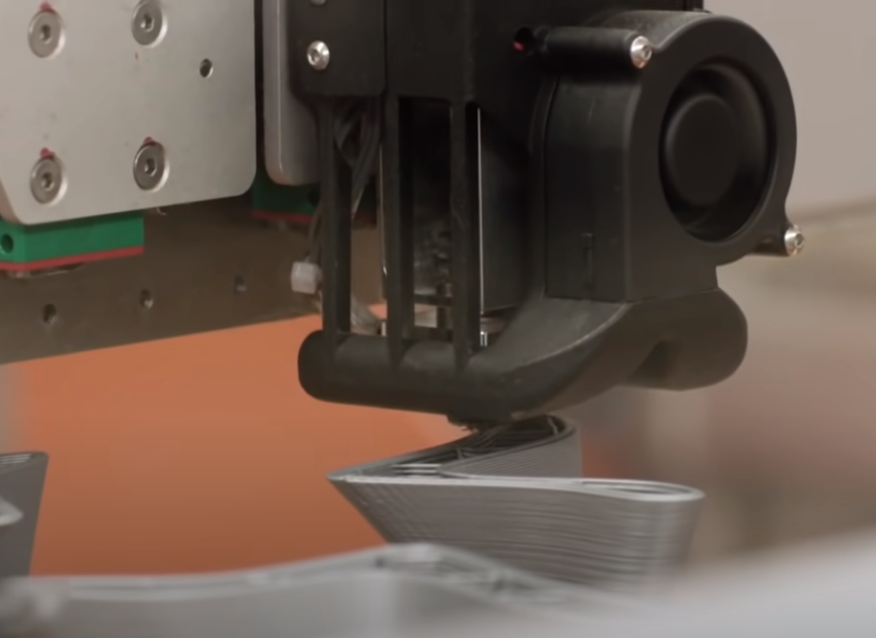
Melted plastic filaments being applied layer by layer

Of course, a 3D printed house is a bit more complicated, although it only takes days to make at a fraction of the cost of conventional construction.

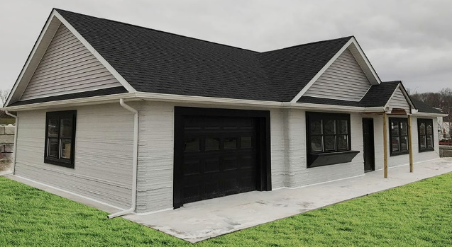

The 3D printing eliminates over 20 manual, labor-intensive processes such as siding, framing, and sheathing and allows completion of a 1900 square foot house in about 48 hours of print time spanning 8 – 10 days.

As technology moves forward and new techniques are used in more applications, more uses are continually discovered.

A hobbyist can get into 3D printing for under $500 and use it to create jigs and tools that can be used for all sorts of practical purposes – or maybe to create unique shapes for the fun of it!!

More information: https://www.youtube.com/watch?v=XHSYEH133HA

